**Create a non government order in ebiz**

1. To create an order in ebiz switches the responsibility to LDB OM WCC. To change responsibility click File>Switch Responsibility > Select LDB OM WCC
2. Navigation window will appear. Select Sales orders and click Open.

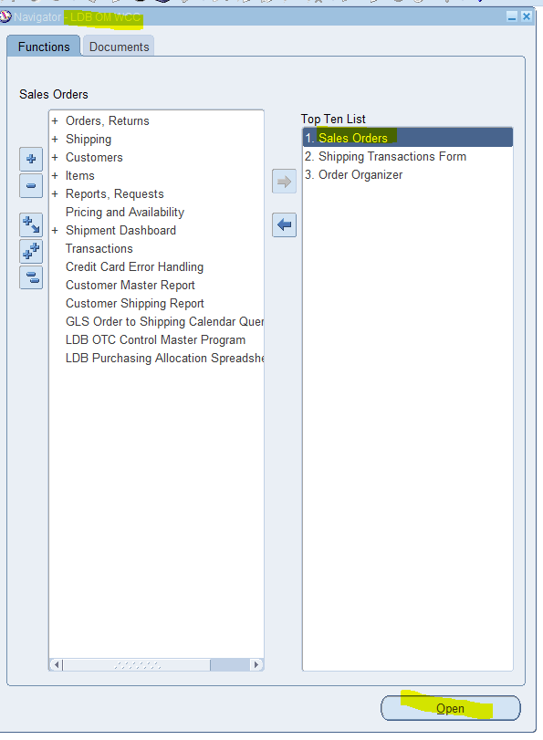

1. Enter Customer and hit enter

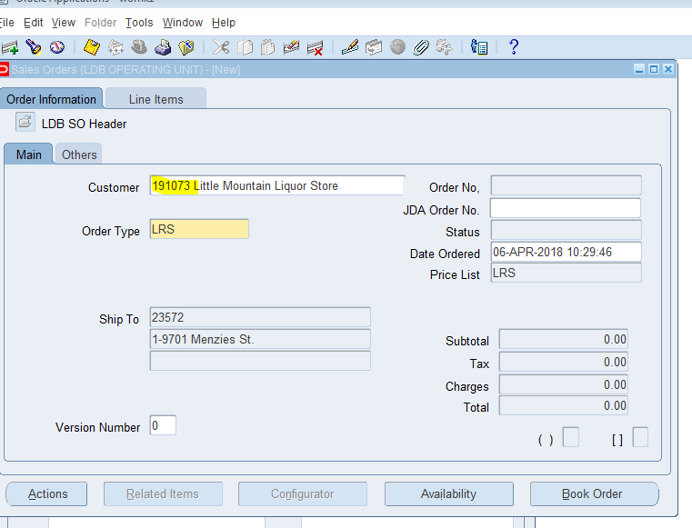

1. Click Line items tab.
2. Enter SKU hit tab and enter QTY. Click Book Order

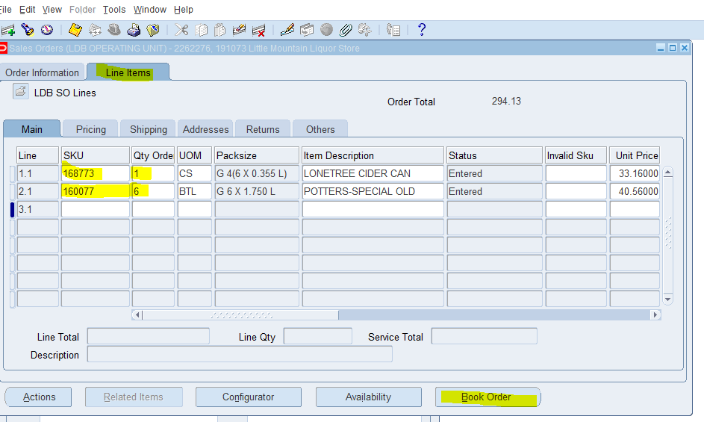

1. Note the Order number and then hit the ok button for the pop up window.

